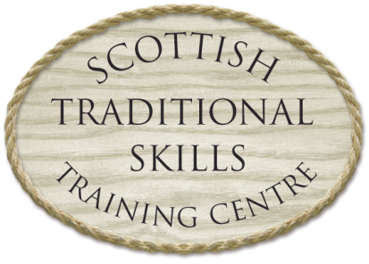

|  |  |
| --- | --- |
| **Building and Repairing Dry Stone Walls**  **- Thursday 21st and Friday 22nd of June, 2018 -** |  |

**COURSE DESCRIPTION:** This 2-day Course will provide hands-on instruction and training in the skills and techniques involved in constructing and repairing Dry Stone Walls – and is aimed at Private Individuals, Estate and Farm Staff, Construction Industry Professionals, as well as those involved in landscape conservation and enhancement projects LCEP.

**LOCATION:** The course, which is being presented by The Scottish Traditional Skills Training Centre, will be held at: The Salmon Bothy, Portsoy, near Banff, AB45 2SS

**NUMBER OF DELEGATES:** Maximum 12 participants

**CERTIFICATION:** Delegates will receive a certificate acknowledging their successful completion of the course.

**TIME:** 9.30 am – 4.30 pm

**CATERING:** Sandwich lunches, as well as tea/coffee will be provided.

**INSTRUCTION:** The course is being led by Euan Thompson, a highly skilled and experienced Dry Stone Waller and Instructor who, in addition to his work with the Scottish Traditional Skills Training Centre, has carried out numerous highly successful walling projects for a wide range of private and public sector clients.

**CLOTHING (PPE):** Those attending will be required to wear stout footwear and outdoor clothing. Boiler suits, hard hats, safety goggles & gloves are provided.

**COURSE FEE:** £175.00 per Delegate. The STSTC is a registered charity and no VAT will be charged.

**REGISTRATION:** Delegate places on the course will be secured by sending a cheque for the course fee of £175 made payable to “The Scottish Traditional Skills Training Centre” by post to: Towie Barclay Castle, Auchterless, Turriff, AB53 8EP. We also accept payment by BACS.

**For further information Telephone: 01888 511347**

**to reserve a place: Email: Soundcraft@towiebarclay.co.uk**

The Scottish Traditional Skills Training Centre

Registered Charity Number: SC 037340

Registered in Scotland No: SC 302744