 

**Europa Nostra UK**

**Annual Meeting**

**Oxford, 17th-20th September, 2018**

**Programme**

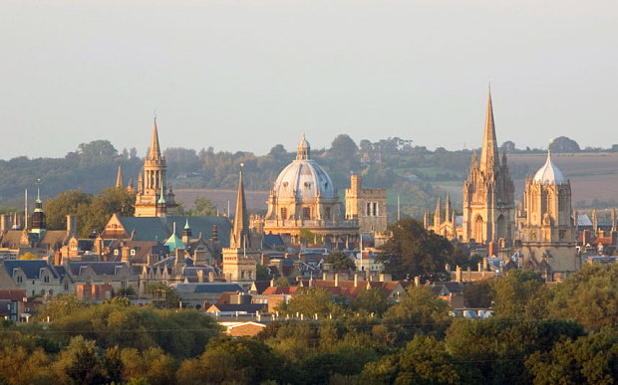

**Sponsors: The Leventis Foundation**

**Monday, 17th September – in St Edmund Hall**

**Welcome** (a glass of wine and an opportunity to register**)  18.30-19.15**

**Dinner in the Old Dining Hall                19.30**

**Tuesday, 18th September**

**A Walking Tour of Oxford:** a tour of some of the major buildings in the University, including private visits to places not usually accessible to the general public. Duke Humphrey’s Library in the Bodleian and the Ashmolean Museum have both won Europa Nostra Awards.

**9.30 departure**

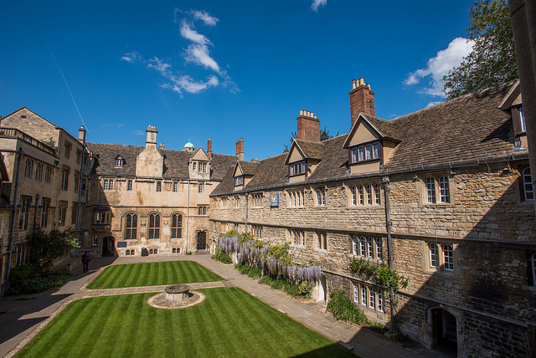

Front Quad, St Edmund Hall

The **afternoon** events will take place in the **Doctorow Hall, St Edmund Hall:**

**Annual General Meeting of Europa Nostra UK                  15.00**

**Tea                                                                                            16.00**

**Duncan-Sandys Lecture                                                         16.30**

The Lecture commemorates Lord Duncan-Sandys who was for many years President of Europa Nostra and led the organisation actively during its early and formative years.  It will be given this year by **Dame Fiona Reynolds,** Master of Emmanuel College, Cambridge, and formerly Director-General of the National Trust. The title of her lecture is

**‘The Fight for Beauty’**

The Lecture will be followed by a **Reception** (canapés and wine)

**Wednesday, 19th September**

**Morning and afternoon in the Doctorow Hall, St Edmund Hall**

**Conference                                                                            9.00-17.30**

**‘European Historic Universities as World Heritage Sites’**

The purpose of this conference is to initiate a pan-European dialogue to strengthen the cultural heritage aspects of European historic universities through a joint initiative. The challenges facing such a grouping will be investigated. Lunch is included.

**Speakers** include Dr Ray Bondin (former Ambassador and Permanent Delegate of Malta to UNESCO), Dr Christopher Young (former Head of World Heritage and International Policy at English Heritage), Debbie Dance (Director of Oxford Preservation Trust). We are awaiting confirmation from three further speakers, and we expect to have talks from senior members of the Universities of Oxford and Coimbra, Portugal.

**Conference Dinner: 19.00 Drinks in the Senior Common Room**

**for 19.30 Dinner in Main Dining Hall**

**Thursday, 20th September**

**A Visit to Blenheim Palace World Heritage Site                   9.30-16.00**

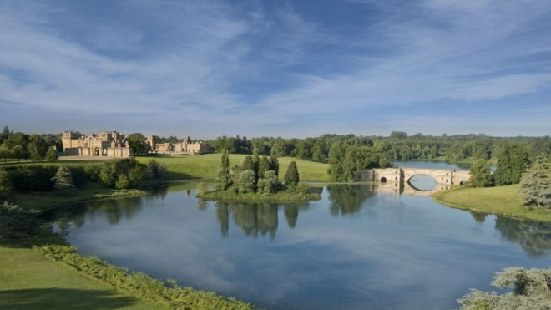

Blenheim Palace Estate

As well as visiting the Palace and Capability Brown’s landscape gardens, we shall be given talks explaining the creative ways the WHS has found to run its famous estate successfully in a modern context.

**A Memorial Service for Angus Fowler will take place in Trinity College Chapel at 5 p.m., followed by a Reception in Trinity College**

All participants at our meeting will be very welcome.

**Farewell Dinner in the Doctorow Hall, St Edmund Hall             19.30**